Content Marketing Strategy
UC Davis’ University Writing Program (UWP) Website

Team Echo: Vishal Patel, Dustin Cai, Nicholas Hausch, Matthew Kyawmyint, Sophie Quynn, Chris Nathan

Table of contents

Executive summary
Content marketing goals
Audience personas
How the audience’s needs match our solutions
Competitive research
Content from the competition
Existing, similar content sources
Content inventory
Evaluation of existing content
What sticks?
What should we fix?
What should we nix?
What should we add to the mix?
Content themes
New content to create
Types of content to create
Estimate of content capacity
Editorial calendar
Content promotion workflow
Summary

Executive summary

Objective
Our primary objective is to increase the web presence of the UC Davis UWP writing website, writing.ucdavis.edu. Our goals are to increase the web traffic leading to the website, to promote student interest in the Writing minor, and to make the current resources and information more accessible.

Current State
The website has had a redesign in the past year or so, which heavily changed the homepage by removing a number of features. The UWP Facebook page and Twitter accounts have a small number of likes and followers, but are an addition in the new version of the site. There's no general contact form, and there's some promoted content on the home page.

Changes
To reach the stated goals of increasing web traffic, we suggest adding more content at a regular schedule. The redesigned website has a number of missing features compared to the old version, so reverting the version could actually be an improvement. UWP should also create a mobile-friendly site to serve more users.

Roadmap
Reverting the website should take no manpower, as long as files are backed up. You could get local writers in the department to help create the suggested content.
Content Marketing Goals

The overall marketing goals for the UWP website include increase in website traffic, promote student interest in the minor, and provide an abundant amount of updated information and resources that students can easily access.

Content accomplishes these goals by

- Providing an opportunity to speak with faculty, administrative staff, and students about what content would be beneficial
- Bringing more visits to the website where people can view the content
- Stay up to date through social media
- Cultivating a community

The great part is we can measure this pretty easily! With traffic, resources, and student interest being the main goal, we’ll find how content is performing to meet our goals.

Key metrics include:

- Unique visits
- Time on site
- Open rate and click rate
- Social Media Followers and Likes

Specific goals:

Goal: To Increase web traffic and
- Objective #1 - 1,000 likes on social media
- Objective #2 - Require UWP classes to implement the website to their courses more.
- Objective #3 - Increase awareness of the site.
- Objective #4 - Produce an online community forum

Goal: To Promote student interest into the minor
- Objective #1 - Hold a story writing event every month for students to write about a topic and win prizes.
- Objective #2 - Go to writing heavy classes to recruit and inform students of the minor

Goal: To have easy access and have abundant information and resources
- Objective #1 - Go back to the old website format style
- Objective #2 - Update site with new information bi-monthly.
- Objective #3 - Provide faster website navigation
- Objective #3 - Revive Social Media Account Activity

Audience Personas

Graduate Student Ashley

Job title: Graduate Student
Seniority: Answers to their graduate advisor

Their overall satisfaction with the UWP website: 8/10

The last time they used the UWP website: The last time they used the UWP website was at the beginning of fall quarter to see what time the course they were teaching was held at.

How they typically interact with the UWP website: As a graduate student, they interact with the UWP website to find out what graduate courses are offered, discover what the required courses for their field are, and locate forms they use to sign up for courses. As a prospective student, they used the site to explore what the UC Davis writing program offered and who the current graduate students were. In particular, they use the PhD Designated Emphasis portion of the site to find graduate students, email them, and keep a conversation going with them. Additionally, they interact with faculty profile web pages to find potential faculty who could serve on their graduate school committees.
How often they use the UWP website: Now that they are done with coursework and writing their dissertation, they generally use it only 3 times a quarter - at the beginning of the quarter to confirm the details of the courses they are teaching, then to update their office hours for the quarter, and then at the end of the quarter to sign up for independent study units with my graduate school advisor, who is in the University Writing Program.

The features/sections of the UWP website they use often: Currently, they use the intranet and the course schedules sections often. In the past they have used the sections for faculty profiles, graduate student profiles, and information on the department.

Things they like and dislike about the website: They like that it has the information that they need in a relatively easy-to-get format. They dislike that the current design is outdated - for example, the fonts and the way the site is a small box centered on the page instead of covering the whole page. Also, they dislike that usability is difficult because most information is embedded in the menus.

If they can’t find information on the UWP website, where they look next: If they are looking for course information, they can also check the university course search tool on the general UC Davis website. However, most of the information they need can only be found on the UWP website.

Problems we can solve for them: Update the website design, add popular links to the homepage, improve the usability of the intranet section, keep the department information up-to-date, add a medium for UWP students to network, and improve the speed of website navigation.

Their goals:
- Find their course information quickly
- Update their office hours information on the site
- Use the UWP website to connect with other UWP graduate students

Faculty Member Kevin

Job title: Faculty Administrator
Seniority: Answers to the head of the UWP department

Their overall satisfaction with the UWP website: 7/10

The last time they used the UWP website: The last time they used the UWP website was to review the staff contact information to figure out which staff member they would need to contact for a specific issue, as well as to find that staff member’s contact information.

How they typically interact with the UWP website: As a faculty administrator, they use the website frequently to find faculty and staff contact information, view the UWP course schedules, view instructors’ student evaluations, find policy information, and post teaching observation reports.

How often they use the UWP website: They use the UWP website almost every day.

The features/sections of the UWP website they use often: They use the faculty and staff directories and course schedules most frequently.

Things they like and dislike about the website: They like the page that highlights faculty successes and the drop-down menu format on the index page. They like that there are pictures of faculty included on the faculty pages and that the information is organized in a concise way. They dislike that the website is not updated regularly and is missing key information, such as information on UWP policies, or contains outdated information, like information regarding add/drop policies. Additionally, while the top level and second level are easy to navigate, they have difficulty navigating through the third level.

If they can’t find information on the UWP website, where they look next: If there is information they can’t find on the UWP website, they check the UC Davis search engine.

Problems we can solve for them: Update information on department policies, improve ease of navigation, include an introduction statement on the UWP department’s purpose and focus on the homepage, ensure every faculty member has a picture, include more information on staff members in the directory. Reduce major information to two clicks from the start of the front page.

Their goals:
- Find staff contact information quickly
- Easily find updated information on UWP policies as well as general department information
- Use the website to view course evaluations

Staff Member Denise

Job title: Staff Member
Seniority: Staff Manager

Their overall satisfaction with the UWP website: 8/10

The last time they used the UWP website: The last time they used the UWP website was to make an appointment with an undergraduate student regarding their personal statement.

How they typically interact with the UWP website: As a staff member, they typically interact with the UWP website to find staff information and information on the courses offered by the UWP department. They use the website to make appointments for graduate students and find contact information for faculty members. Additionally, they work with the webmaster to schedule courses and use the website to gather data regarding what courses are being offered and at what time.

How often they use the UWP website: They use the website more than once per day.

The features/sections of the UWP website they use often: They often use the website to find information on the UWP minor while they are helping students figure out what courses they need to take for the minor. Additionally, they use the website to schedule course information and find contact information.

Things they like and dislike about the website: They like that they are able to locate contact information and office hours information quickly. Also, they like that they are able to work with the webmaster to query faculty on what courses they want to teach and which courses they are teaching now - the webmaster gives them a link to the information on who is teaching what in the UWP department. They dislike that navigating through the website is difficult and that certain information is hard to find. Specifically, the upper division exam information is hidden behind various links and it is hard to find information on when the exam is offered and how often you can take the exam.

If they can’t find information on the UWP website, where they look next: If there is information they can’t find on the UWP website, they check the UC Davis website or look through a hard-copy of the UWP policies.

Problems we can solve for them: Update the aesthetic of the website, make the information on the upper division writing exam easier to access, improve navigation of the website, maintain a section on writing information similar to Purdue OWL.

Their goals:
- Access information on the upper division writing exam
- Use the website to create course schedules
- Find staff information quickly
- Easily find information on the UWP minor

How The Audience’s Needs Match Our Solutions

Various Audience Personas | Goals | Our Solutions
Graduate Student Ashley | - Find their course information quickly  - Update their office hours information on the site  - Use the UWP website to connect with other UWP graduate students | - Update user interface for the website  - Provide a community forum for graduate students
Faculty Member Kevin | - Find staff contact information quickly  - Easily find updated information on UWP policies as well as general department information  - Use the website to view course evaluations | - Update user interface for the website  - Keep department information up to date and make it easily accessible from the staff section of the website  - Limit major information to two clicks from the front page
Staff Member Denise | - Access information on the upper division writing exam  - Use the website to create course schedules  - Find staff information quickly  - Easily find information on the UWP minor | - Update user interface for the website  - Limit major information to two clicks from the front page  - Update UWP minor and upper division writing exam information and make it easily accessible from the front page

Competitive Research

Content from the competition

People turn to a university’s writing website for a number of reasons. The most common reason is to get information about the program quickly. A university that does this well is the University of California at Los Angeles Writing Program website located at http://wp.ucla.edu/wp.
We can immediately see that the information in their website is easy to use. The information is clearly laid out and easy to read and understand where to find the appropriate information.

How can we stand out?

If the school spends time and resources updating the user interface and creating a mobile site, we feel that the website would garner a lot more views and traffic to the site. In this day and age a big portion of the population accesses the internet using their mobile device. We feel that if there was a mobile site in which it would be easy to access information, there would be a lot more people attempting to use the website. We also feel that if there was an updated user interface for the website there would be a lot more people going to the website for information.

Heroes: http://wp.ucla.edu/wp
Watering Holes: https://owl.english.purdue.edu/owl/

Content Inventory

These are the high-level web pages:

- Home page - http://writing.ucdavis.edu/
- About - http://writing.ucdavis.edu/about
- Academics - http://writing.ucdavis.edu/academics/course-schedules
- People - http://writing.ucdavis.edu/people/directory
- Publications - http://writing.ucdavis.edu/publications
- Programs and Services - http://writing.ucdavis.edu/programs-services

These are the social media accounts:

- Twitter - @writingprogram - 336 followers
- Facebook - https://www.facebook.com/UC-Davis-University-Writing-Program-UWP-231152496964142/ -

Evaluation of Existing Content

What sticks?
- Quick Links
- Directory
- Course Schedule
- Course Information

What should we fix?
- Up-to-date information
- Website Front Page
- Website Menus
- Social Media Accounts

What should we nix?
- None

What should we add to the mix?
- Contact Form
- Welcome Message
- More Quick Links for Common Searches
- Mobile-friendly website
- Community Forum

Content Themes

Content that Resonates:
Course Schedules, Course Descriptions, Directory, Faculty, Faculty Administrators, Graduate Student Instructors, Staff, Office Hours, Graduate Studies, Writing Minor

Why that might be:
Website revolves around information about the writing courses. Graduate students need information about their graduate studies and updating their office hours. Students will also search for their english requirements and a possible writing minor. Faculty Administrators and staff need course informations to review or update.

Content that needs fixing:
Website Front page, Menus, News, Social Media Accounts

Why that might be:
The front page does not offer much introduction to the UWP department, leaving disorientation. Information may be embedded within layers of menus, making searching a hassle. Restricting major information to two clicks starting from the beginning of the front page would alleviate this problem. News may be difficult to catch with the passive feature on the front page. Inactive social media accounts also does not help this. Reviving these accounts and creating a website news feed will keep both students and faculty informed.

Content we can add:
Contact form, Quick Links, Mobile Site, Community forum, Welcome Message

What that might help:
Contact forms and information displayed on the front page instead of the menu will deliver important information to users faster. Quick links for commonly used staff and administrator information will provide ease for our faculty. A community forum that allows student to communicate, blog and get to know each other would foster a sense of community for UWP students. Professors can also give insight or answers to students in these forums. Providing a brief welcome message on the front page will give an insight for new users that are interested in UWP. Adding a mobile site can provide an easier, friendly access for people that want to use the website on their phone.

New Content to Create

Additions that could make a positive impact:

- More publications. Currently, the website only contains some links to ‘Prized Writing’, a contest for undergraduates, and ‘Writing on the Edge’, a journal for writing teachers. A wider variety of writing from faculty and graduate students would help expand the website’s appeal.
- Quick Links. The website needs a short list of commonly visited pages that can be easily accessed from the main pages.
- User feedback. A form that users can use to ask questions or submit feedback to the department.
- Mobile website. A trimmed down version of the website that provides a user friendly phone/tablet experience.
- Newsfeed. A central page for news updates and publications, where users can leave comments and provide feedback.
- Community Forum. A page or platform for students to network and communicate. Garners attention and more students.
- Welcome Message. A welcome message or purpose statement on the front page for users to have a brief introduction of the writing department.

Estimate of content capacity

Who's the team?

The team consists of Elliot “The Codebreaker” Pollard. He is the sole “webmaster” and creator of the current UWP website. Elliot prides himself on the impact he’s made to the university’s online evaluation system, despite it lowering student participation dramatically. Elliot despises mobile websites “because they’re just stupid, man.” He is also responsible for the humanities department website. He is not overly concerned with the website’s image because “although we don’t have a major, everyone has to take writing anyway, so one way or another we’re going to get you.”

What's the workflow?

Elliot admitted he does not work on the website very much, aside from updating quarterly information. His main workflow consists of handling the school’s online evaluation system and updating his fantasy lineups.

Moving forward..

Elliot will not likely make any major changes soon, as he is very set in his ways. However, with consistent encouragement from Writing faculty and staff, maybe he could be persuaded. Until then, we can only hope.

Editorial Calendar

Frequency:

News Update: Post regular updates and news biweekly. Update important policies and information immediately. Schedule these on Mondays when people begin their work week.

Twitter posts: Post regular updates and news biweekly simultaneously as the website. Have the official UC Davis twitter account retweet the department’s tweets.

Facebook posts: Return using the facebook account. Post regularly the same information from the Twitter account.

Writing Contests: Host monthly writing contests near the beginning of every month.
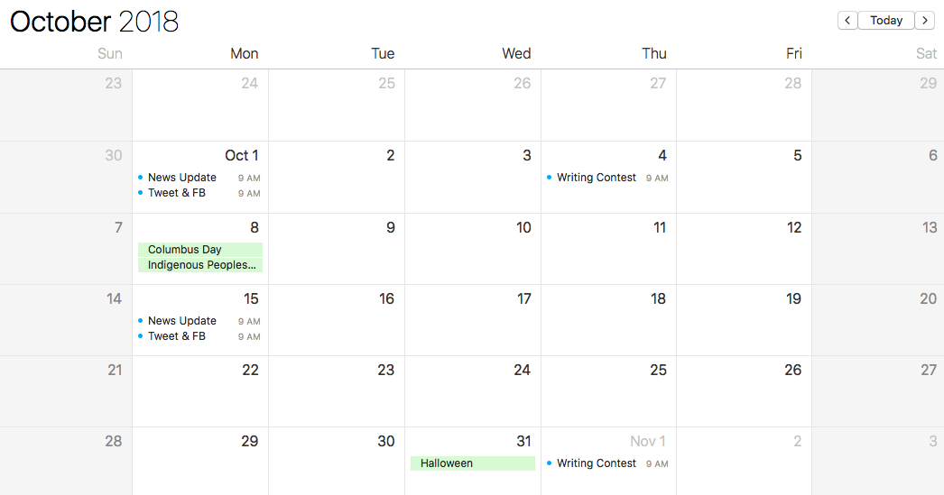

Content Promotion Workflow

For every news:

- Post on website newsfeed
- Post on Facebook
- Post on Twitter

For every monthly writing contest:

- Post on website newsfeed
- Post of Facebook
- Post on Twitter
- Reach out to UC Davis account to retweet our posts

Summary

The UC Davis writing department has opportunity for growth because of the UWP requirement. Every student needs to interact with the writing department to get a degree, so there's an opportunity to positively impact each UCD student with the website. If the website design was modern, clean, and easy to navigate, then students will have a better experience using the site and fulfilling their requirements. Reverting the site would bring back some crucial features like a Contact form, better news features, and a cleaner UI, and reverting would be easy to do with backups. Upgrading the website to handle mobile visitors is crucial in this day and age, where >50% of all web traffic comes from mobile devices. Creating new, engaging content on a regular timeline could also start to grow the amount of active visitors who aren't just trying to find UWP requirements. Graduate students could also benefit from a community forum, and could keep them returning to the site as regular active visitors. Given focused marketing goals and clear action items to improve, the UWP writing website could have a better online presence and simultaneously grow the engagement of its community.

