Exploring to an Online Game Community

Abstract
This research paper is exploring an online community, game group on the discord, and to find what are the effects on members has by this group and games. In my primary research, I found a target group on the Discord, a platform that provides text and voice channels for gamers, and observed it in five days. After getting some interesting observations, I narrowed down the topics and designed some relative questions to interview the administrator and some group members. Finally, I foucued the topic on the effects of the group and games have on people both on positive and negative sides, and found the secondary sources about them. PsychGuides gives me some ideas of why people addicted to games, and Nuyens et al.’s analysis of MOBA also helps me to understand game addiction.

Introduction
Playing games is a very common form of entertainment in life. With the development of games over the years, more and more different games appear like MOBA, MMORPG, online multiplayer battle royale games and so on. ESports is becoming accepted as a sport, and many game competitions are held every year. Olsen(2015) found that “the trend analysis further expects a 305.51% growth in the live audience from 2014-2019, while the virtual streaming audience is expected to experience a growth of 140.61%.” As the increasing people focus and joined in eSports, the online community for it is also developed quickly.
As a gaming enthusiast, I was invited to a private game group by my friends, and I think it is a good chance and target to observe how an online group works and what effects it has.

Method
This research was conducted by doing a primary research and secondary research. My primary research is to observe an online game group on the discord for five days, and record some data like how many members are online at a fixed time period of 9 p.m. In addition to observation, I also interviewed some members and the creator of this group.
Here are some interview questions for group administrator:
- What’s the reason for you to create this group?
- Do you think it is necessary to add rules to this group?
- Does this group runs as you expected?
- Besides playing games, have you organized offline parties?
Here are some interview questions for the group members:
- How and why did you join this group?
- Do you often participate in group activities?
- Do you have more motivation to play the game after joining this group?(spending more time on gaming)
I was invited to this group once my friend and I were playing games and we want to use the voice channel in the discord. I have joined this group for about 3 months, and I only know a few group members in real life. All interviewers are strangers to me to reduce the bias. For example, If I only interviewed how often my friends, who play games almost every day, participate in the group activities, the results may not represent the whole group. Thus, the interviewers are selected randomly.
Searching for sources on the internet constitutes my secondary research. I used UC Davis library database, google scholar and journals to find relevant sources both academic and non-academic, and test their credibility.

Findings and analysis
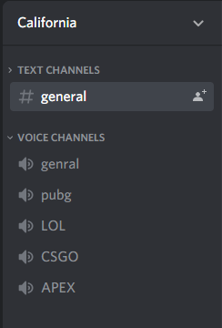
The figure on the left side is the homepage of this group. “California” is the name of this group. The creator told me it is because most of the group members were students studying in California when the group was first formed. There is a text channels and voice channels. In the general channel under the text channels, people can chat in words or share game picture and video. Under the voice channels which is usually used during a game communication, there are four games that this group prefers to play, and when you are playing games with them, you can go to the specific channel to start a voice communication.

- For the general information of this group, I found that there are 80 members in the group, and the language they use is chinese. I think it is because most group members are from China and study in California. I also found it is a private group that no rule in this group, and then I have asked administrator some relative questions.
  - Q: what’s the reason for you to create the group?
    - Administrator: I created this group 2 years ago with my friends. Although the name is California, it did not mean it was an open group for California gaming enthusiasts. This private group was built just because it was convenient to have voice communication with my friends when playing games. And there were just 6 people in this group at first.
  - Q: As more and more joined in the group, do you think it is necessary to set rules?
    - Administrator: I do not think this group need rules. Although now it has 80 people, everyone gets along well with each other without any contraction. People just get together for the same interests, and want to find someone to play games with. This is the only reason for the existence of this group.
  - Q: Does this group runs as you expected?
    - Administrator: As I said before, I only view this group as a platform to voice chat with several of my several friends. I did not expected that there are many people I did know joined this group. Maybe they are my friends’ friends.
  - Q: what do you think about more and more strangers joined group? Is it a good or bad thing?
    - At first I think more strangers make this group does not as private as before. But I think it is a good thing to group gaming enthusiasts together. We can discuss game strategy, find five people together to have a team game, and make new friends.

- One important observation I have is that they use the voice channel more than text channel. In the five observation days, I seldom see they chat many in text, that about 6 or 7 messages per day; while some members will have hours of voice chat. The most frequently used words I can see in the text channel is “does anyone want to play a game?” Even sometimes, they only type a number or a question mark without any other words to show that they are ready to play games, and then move to the voice channel. I think the reason is that a voice communication is more effective, especially in a team game.

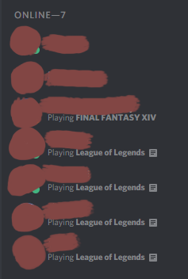
- In the five days of observation, I also recorded how many people are online and what game they were playing. One interesting observation is that although it is not a League of Legends gamer group, that also include other games’ voice channel, most group members are playing League of Legends. For example, the figure on the left side shows there are seven members are online, four of them are playing League of Legends, only one person is playing Final Fantasy XIV, and two people did not show show their state(maybe they are not playing games). I have recorded what games they played in five days. The below graph shows the data.
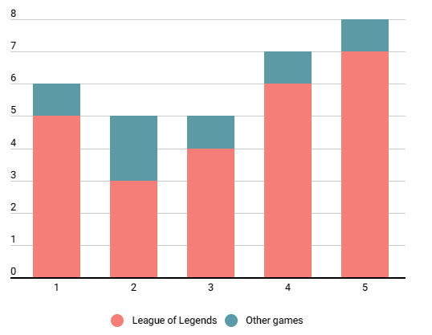
Because they are very few people playing other games except League of Legends, I did not write what other games are.
I interviewed some group members:
  - Q:How and why did you join this group?
    - A: One friend invited me to the group to have a voice communication when playing League of Legends.
  - Q: Do you often participate in group activities?
    - Maybe about three times a week? Sometimes I just play games individually. When I want to have a team game, I will participate with them.
I think one possible reason for more people playing League of Legends is that it is a team game. Discord is a platform that provides voice communication during gaming. Thus, I think Discord users are gamers who like the team games that need communication with teammates more than other single-player games or MMORPG(massively multiplayer online role-playing game). Secondly, maybe the MOBA makes people become addicted to games easier. Nuyens et al.(2016) says in their research paper League and Legends “had 67 million monthly players in 2014. In contrast to MMORPGs, MOBA games do not take place in never-ending virtual worlds, although they feature similar characteristics of advancement and social interaction. Importantly, LoL provides daily updated international rankings and statistics, and is the game most associated with international competitions (including a worldwide championship) and eSport practices”. Due to the update ranking, gamer will play the game hard to have a high rank, and it will never end, since it is updating. People also become addicted to it because the game makes them want to play one more game. My friends and including myself often stay up late playing games, because when I lose I want to play one more to offset the deduction in my score; while when I win I want to play one more because I think I am in a good state. Also the company of friends also makes people spend more time on games. Here is an interview question I asked one group member.
  - Q: Do you have more motivation to play the game after joining this group?(spending more time on gaming)
    - Member A: Yes. Before joining this group, it would be boring to play games alone. So sometimes I don’t play games for a week if there’s no one to play with. Also sometimes people would talk about the game strategies in the group. When I heard these strategies, I would like to open the game and try these strategies myself.
Playing team games with friends is much more interesting than playing lonely, and people will be motivated when others are talking about something you are interested in.
    - Member B: I think joining the group did not affect the time I play. As a student, I have a lot of work to do. Thus, I will control my leisure time generally, like playing games on weekends, or sometimes, I just does not have time to play games.
If you have good self-control, joining a game group will not make you more addicted to the game.

- Besides some negative effect like time-consuming, this group also brings some positive effects. Firstly, the online group provide a very good platform to make friends. Building friendship is one of the positive effects of gaming(Bamford, 2018). For example, one of my friends start to play games and joined in the group this year. He said he wanted to play it long before, but he cannot find people who can teach him how to play. After playing games together, our relationship became better. For Example, we often have classes and have dinner together, not just playing games online. Based on my own experience, I interviewed the administrator about this question.
  - Q: Besides playing games, have you organized offline parties?
    - Administrator: No, I did not organized an offline party, but since most people in the group are also know each other in real life, we also meet offline. And since most members are students in UCDavis, becoming friends in real life after playing games together is very normal. And I am also being benefited as the administrator that my social circle expanded.
Like the administrator said, many people in this group become friends.
Secondly, after looking for many secondary resources, I found that playing games is beneficial for learning ability. The American Psychological Association(2013) says that “a 2013 meta-analysis found that playing shooter video games improved a player’s capacity to think about objects in three dimensions, just as well as academic courses to enhance these same skills, according to the study.” it shows that playing games can practice our mental thinking ability.
The American Psychological Association(2013) also mentioned that playing games “can improve players’ moods, promote relaxation and ward off anxiety”. I think people need to find a proper way to release their pressure when people are depressed. The way can be sleeping, eating or singing, and for me, also for the most people in a group, one way is playing games, because games will distract attention. What’s more, in general, my friends who are playing games with me will feel me emotion when I am unhappy, then they will comfort me. I will feel much better when have someone to talk with.

Conclusion
This research paper talks about a 5-days-observation of a game group on discord. There are many interesting observations like their different communication ways and what games they played most. After looking at all general information about this group, I focus the topic on both the positive effects and negative effects takes by playing games and joining game group. I found that one special strategy for game producers to attract gamer is the updated ranking, which stimulate players playing to keep their rankings. Also, joining a game group will motivate people spend more time on games because once you are in this community, you will know more about games. Thus, the online game community may make people addicted to games. However, like one interviewer said that he can control himself because he knows playing too much games will affect his study, there are also many positive effects if you can find the balance between the virtual game world and reality. For example, many people in this group who are strangers before, become friends in real life since they share the same hobbies and both they are studying in UCDavis. Also the study shows playing games also benefit people in mental health and mental learning ability. Although playing games is a double-edged sword, I want to encourage people to join a community that share the same hobbies as you, which will make our life richer spiritually.

Reference
Nuyens, F. et al.(2016). Impulsivity in Multiplayer Online Battle Arena Gamers: Preliminary Results on Experimental and Self-Report Measures. Retrieved from: https://www.ncbi.nlm.nih.gov/pmc/articles/PMC5387787/

PsychGuides(n.d.). Video Game Addiction Symptoms, Causes and Effects. Retrieved from: https://www.psychguides.com/behavioral-disorders/video-game-addiction/

Olsen, A.H.(2015). The Evolution of eSports: An Analysis of its origin and a look at its prospective future growth as enhanced by Information Technology Management tools. Retrieved from: https://arxiv.org/abs/1509.08795

Bamford, A.(2018). 3 positive effects of gaming. Retrieved from:https://fulleryouthinstitute.org/blog/3-positive-effects-of-gaming

American Psychological Association(2013). Video Games Play May Provide Learning, Health, Social Benefits, Review Finds. Retrieved from: https://www.apa.org/news/press/releases/2013/11/video-games

