<Client Name>
Content Overlay and Page Table Templates

Content Overlays
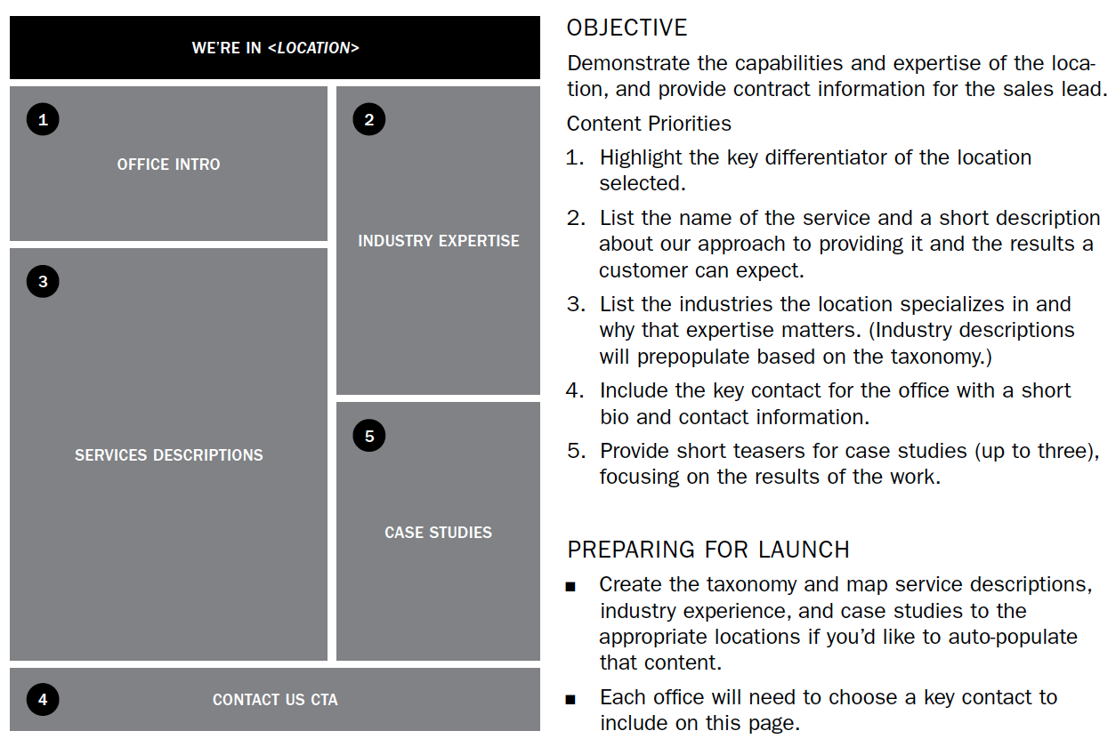
Use content overlays to provide specifications and recommendations about a unique page type, such as the home page, or a repeatable page type. The overlays can supplement your wireframes to add more specific information about content. Some practitioners combine content overlays with their functional wireframes. Just keep in mind who needs to be able to understand, use, and approve what you produce.
On the next page, you’ll find a template you can use to create your own content overlay. I typically create my diagrams in Omnigraffle, but you can do something super simple in Microsoft Word by playing around with table formatting as shown in the template. Here’s an example of a content overlay from page 181 of The Content Strategy Toolkit.

<Template/Page Name>
1. <Description of content> |  | OBJECTIVE  <Objective of the page type>  CONTENT PRIORITIES  - <Description of content priority.>  - <Description of content priority.>  - <Description of content priority.>  - <Description of content priority.>  <KEY INFORMATION HEADING>  - <Key point related to content.>  - <Key point related to content.>  - <Key point related to content.>  - <Key point related to content.>
2. <Description of content> | 3. <Description of content>
4. <Description of content>

Page Tables
Use page tables when you need to be really specific about the content that’s needed on a given page or when you want a subject matter expert to review an outline before you get started.
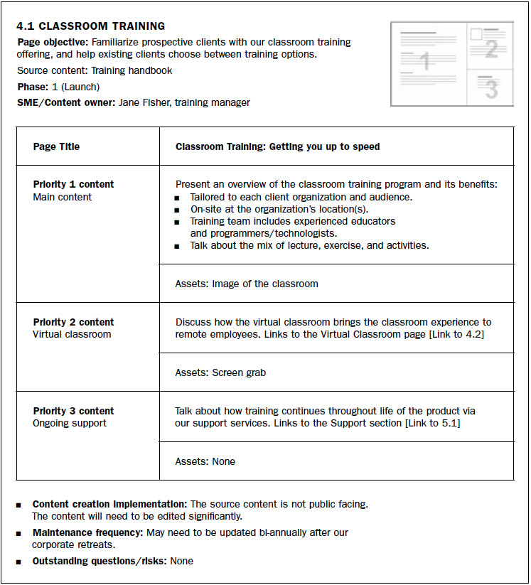
On the next page, you’ll find a template you can use to create your own. You may need to add or delete items to meet the needs of your project. Here’s an example of a page table from page 182 of The Content Strategy Toolkit.

<Page ID> | <Page Name>
Descriptor Tag | <Page description that should show up in search results>
Keywords | <List of key words that should appear on page>
Template | <Template Name>
Page Objective | <Page objective>
Primary Use Cases | - <User scenario statement>  - <User scenario statement>  - <User scenario statement>
Source Content | <List of source content, including SME>
Governance/Maintenance | Owner: <Name>  Update Frequency: <Timeframe>
<Component Name> |  | <Description of specific content to be included>
<Component Name> |  | <Description of specific content to be included>
<Component Name> |  | <Description of specific content to be included>
<Component Name> |  | <Description of specific content to be included>
<Component Name> |  | <Description of specific content to be included>

